**Assignment 15.2**

**1 )**

**def** SUM(a:Int,b:Int,c:Int) = a+b+c  
**val** partial = SUM(5, _:Int,_:Int)  
**def** squr(a:Int):Int={a*a}  
squr(partial(6,8))

**Output**

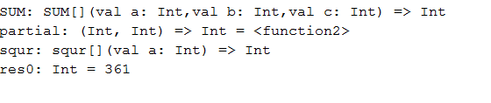

**2)**

object HelloWorld {

def main(args: Array[String]) {

matchTest("Big Data Development")

}

def matchTest(x: String): Unit = x match {

case"Android" => println("Price for Android programming is 12999")

case"Big Data Development" => println("Price for BigData development is 1799")

case"Big Data Administration" => println("Price for BigData Administrations is 17999")

case"Spark" => println("Price for Spark course is 19999")

case _ => println("Not Found")

}

}

**OUTPUT**



object HelloWorld {

def main(args: Array[String]) {

matchTest("Scala")

}

def matchTest(x: String): Unit = x match {

case"Android" => println("Price for Android programming is 12999")

case"Big Data Development" => println("Price for BigData development is 1799")

case"Big Data Administration" => println("Price for BigData Administrations is 17999")

case"Spark" => println("Price for Spark course is 19999")

case _ => println("Not Found")

}

}

OUTPUT

